# Scope of Work Summary

## Summary of Solution

The Solution is a web based application developed on .Net 4.5 Framework served as platform to service fund fact sheet generation automation. The main functionalities provided by the solution are cloud hosting, fund fact sheet management & generation.

## System Architecture Diagram

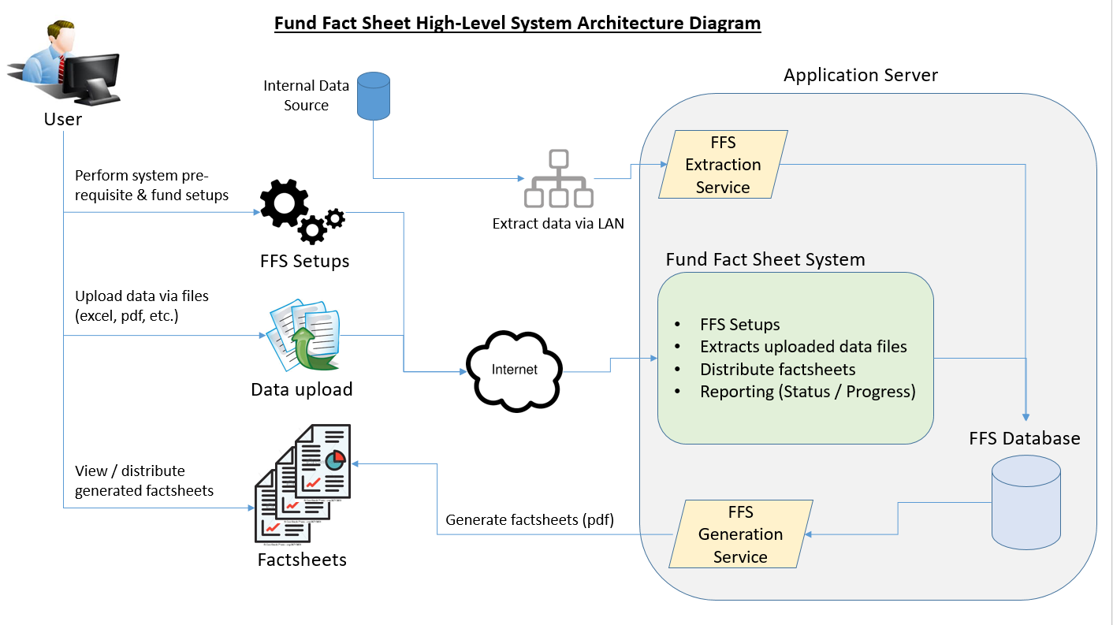

## Scope of Work

The scope of work is as follow:

Fund Fact Sheet Generation System

1. User Login
   * Login authentication by User ID and password.
2. User Management
   * Create / Edit system users.
3. User Access Control
   * Manages user access within FFS Generation System.
4. System Parameters Setup
   * FFS Generation System pre-requisite setup
5. Fund Setup
   * Create funds (FFS Master data setup, fund template management, client management, ETC.)
6. File Extraction, Data Extraction
   * FFS data extraction via files / integration to RHBIB data sources.
7. FFS Update
   * Manual data input by authenticated users.
8. Fund Fact Sheet Review / Compliance
   * Enable FFS review / compliant processes.
9. Fund Fact Sheet Generation
   * FFS generation upon approval.
10. FFS Distribution
    * Fact sheet distribution via email to respective clients.
11. Reports
    * Provide FFS progress related reports (monthly / yearly)

## 

## Assumptions and Dependencies

Fund Fact Sheet Generation System is template driven and depends solely on crystal report templates to cater for different layout variations or different IUTA requirements while still sharing common fund information / performance data.

|  |  |  |
| --- | --- | --- |
| No. | Template | Sample Fund Fact Sheet |
| 1 | RHBIB |  |
| 2 | Standard Chartered |  |

# Services



## Development & Code Review and Testing

|  |  |  |
| --- | --- | --- |
| **Objectives** | * Carry out development as per the design document and coding standards | |
| **Entry Criteria** | * Functional and Technical Specifications Document Sign Off | |
| **Vendor Task** | | **RHBIB Task** |
| * Develop the customized application * Review of the source codes * Perform unit testing | | * Internal testing report |
| **Work Product** | * IIS | |
| **Deliverable Material** | * Source codes | |
| **Completion/Exit Criteria** | * Completion of all Vendor tasks and RHBIB sign-off on all Deliverable Materials listed for this step. | |

## System Integration Testing

|  |  |  |
| --- | --- | --- |
| **Objectives** | Test plan and SIT test cases/scripts will be used to perform System Integration Testing for the project. | |
| **Entry Criteria** | * Completion of application development | |
| **Vendor Task** | | **RHBIB Task** |
| * Perform SIT * Provide error log and report * Resolve and fix errors and bugs reported. | | * Provide access to SIT environment * Validate error log and report produced * SIT sign-off |
| **Work Product** | Conduct SIT and maintain error log | |
| **Deliverable Material** | * SIT Error Log * SIT sign-off | |
| **Completion/Exit Criteria** | * Completion of all Vendor tasks and Bank sign-off on all Deliverable Materials listed for this step. | |

## User Acceptance Testing

|  |  |  |
| --- | --- | --- |
| **Objectives** | * Perform system testing to ensure system meet the requirements set earlier | |
| **Entry Criteria** | * Completion of System Integration Testing | |
| Vendor Task | | RHBIB Task |
| * Facilitate UAT session * Resolve and fix errors and bugs reported. | | * Provide logistic for UAT session * Perform UAT * UAT sign-off |
| **Work Product** | * UAT progress reporting * Maintain UAT error log | |
| **Deliverable Material** | * Periodic UAT progress report * UAT Error Log * UAT Sign-Off | |
| **Completion/Exit Criteria** | * Completion of all Vendor and Bank tasks. * Passed UAT Test Cases. * Resolved & fixed errors and bugs reported | |